THANK YOU FOR HELPING US KEEP THE FACILITY
A SAFE SPACE FOR EVERYONE!

Measures to avoid crowding at the facility room

- Only one user per system is allowed during peak hours (9:00 to 18:00). Up to two, during non-peak hours, only if no one is using the neighboring systems.
- Book the machines using your own credentials, so that everyone´s contacts can be eventually traced, if required.
- Avoid spontaneous visits on issues that can be solved by phone, e-mail or remote connection.
- If you are going to need assistance, schedule it with us in advanced.

General safety protocol for using the microscopes

- Always wear your community mask for mouth-face protection.
- Disinfect your hands when entering the room, whether you are using gloves or not, using 70% EtOH (we also have hydroalcoholic gel for bare hands, if you prefer).
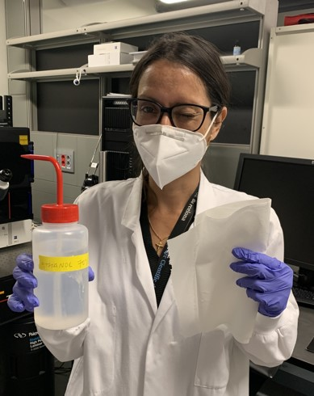
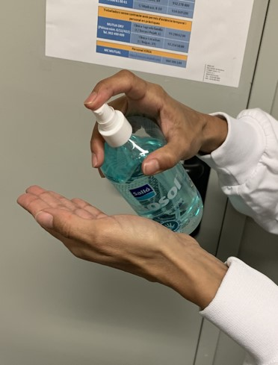

- Before and after working in a microscope/computer, disinfect all commonly touched surfaces with 70% EtOH using kitchen roll paper. This includes: Focus wheel, keyboard and mouse, mouse pad, stage controller/joystick, touch screens, table, oil bottle, anything else that is commonly touched.
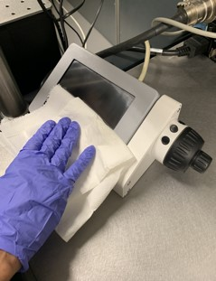
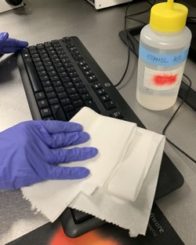
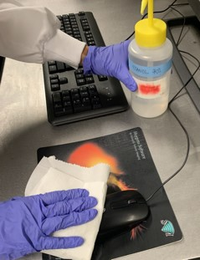
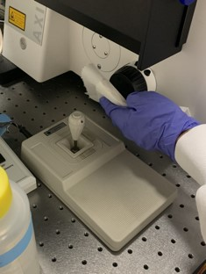
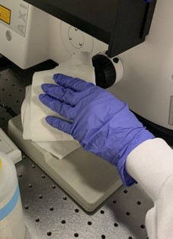

- EYEPIECES. Before and after your session, disinfect the eyepieces using 70% EtOH and optical paper (never standard paper, they can get scratched!!). Additionally, you can carefully cover both oculars (including the area above and below) with cling film. Remove and discard the paper when you finish your session.
